**PROJECT REPORT**

Electronics and Design Workshop (ECECC09)



**Submitted to:** Prof. D. V. Gadre

**Submitted By:** Rishabh Thakur (2020UEC2529)

Akshay Gupta (2020UEC2548)

Dev Sharma (2020UEC2560)

**BLUETOOTH PULSE OXIMETER**

This project is our attempt to implement the functionality of a basic pulse oximeter having Bluetooth data transfer capabilities. Using a MAX30100 pulse oximetry sensor and the HC-05 Bluetooth module. Controlled by Arduino Nano and powered by a 9v battery. The PCB and the enclosure for the project are designed and fabricated in the laboratory itself.

The device pairs with a mobile phone and can display the data on a mobile app, also the readings of the sensor are displayed on an OLED screen.

***ACKNOWLEDGEMENT***

*Before we dive deeper into the project, we would like to thank professor D.V. Gadre without whom this project would still be an idea. We would like to thank for giving us this opportunity to explore the world of applied electronics and guiding us with his valuable feedback throughout the ideation, conceptualisation and prototyping phases of the project.*

**Brief description of the electronic components used in the project**

1. **Arduino nano:**

This Arduino Nano is Original Arduino Nano Board. It is a breadboard-friendly board based on the ATmega328P from Arduino officials made in Italy. It has more or less the same functionality of the Arduino Duemilanove but in a different package. It lacks only a DC power jack and works with a Mini-B USB cable instead of a standard one.

Original Arduino Nano is a surface mount breadboard embedded version with integrated USB. It is the smallest, complete, and breadboard-friendly. It has everything that Diecimila/Duemilanove has (electrically) with more analog input pins and onboard +5V AREF jumper. Physically, it is missing power jack. The Nano is automatically sensing and switch to the higher potential source of power, there is no need for the power select jumper.

Nano’s got the breadboard-ability of the Boarduino and the Mini+USB with a smaller footprint than either, so users have more breadboard space. It’s got a pin layout that works well with the Mini or the Basic Stamp (TX, RX, ATN, GND on one top, power and ground on the other). This new version 3.0 comes with ATMEGA328 which offers more programming and data memory space. It is two layers. That makes it easier to hack and more affordable.

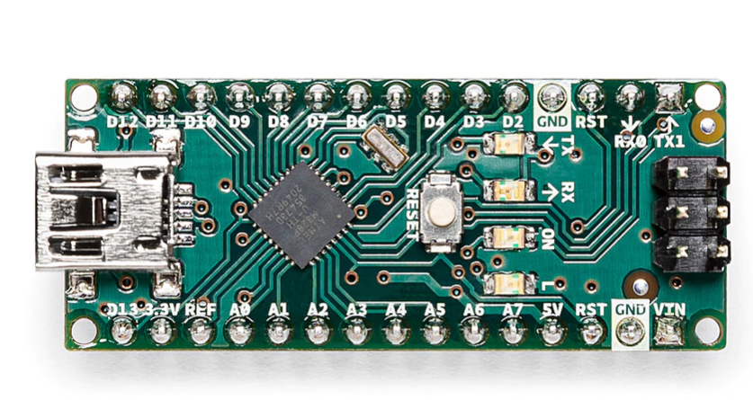

1. **Max30100 pulse oximetry sensor:**

Maxim’s**MAX30100** integrated pulse oximetry and a heart-rate sensor. It’s an **optical sensor that derives its readings from emitting two wavelengths of light from two LED**s – a red and an infrared one – then **measuring the absorbance of pulsing blood through a photodetector**. This particular LED color combination is optimized for reading the data through the tip of one’s finger.

The signal is processed by a **low-noise analog signal processing unit and communicated to the target MCU through the mikroBUS I2C interface**. Developers of end-user applications should note that the readings can be negatively impacted by excess motion and changes in temperature. Also, too much pressure can constrict capillary blood flow and therefore diminish the reliability of the data. A programmable **INT pin** is also available. The **operates at the 3.3V power supply**.

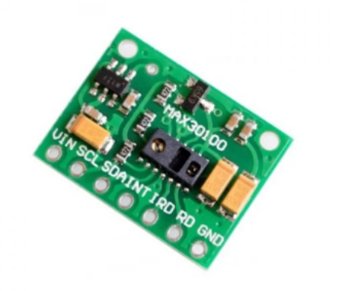

1. **Hc-05 bluetooth module:**

HC-05 6 Pin Wireless Serial Bluetooth Module is a Bluetooth module for use with any microcontroller.  It uses the UART protocol to make it easy to send and receive data wirelessly.

The HC-06 module is a slave only device.  This means that it can connect to most phones and computers with Bluetooth but it cannot connect to another slave-only device such as keyboards and other HC-06 modules.  To connect with other slave devices a master module would be necessary such as the HC-05 version which can do both master and slave.

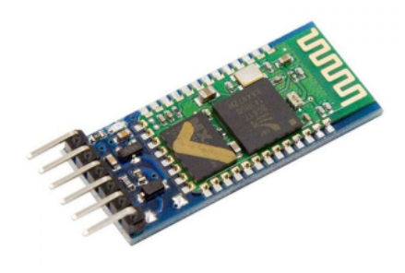

1. **I2C 0.96” OLED screen**

This 0.96” I2C OLED Display is an OLED monochrome 128×64 dot matrix display module with I2C Interface. It is perfect when you need an ultra-small display. Comparing to LCD, OLED screens are way more competitive, which has a number of advantages such as high brightness, self-emission, high contrast ratio, slim outline, wide viewing angle, wide temperature range, and low power consumption. It is compatible with any 3.3V-5V microcontroller, such as Arduino.

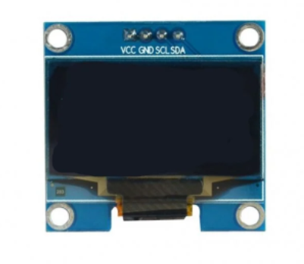

1. **9v battery**

This is General purpose 9V Original HW marked Non-Rechargeable Battery. Its Universal 9V battery size and connecting points; it is useful in many DIY projects as well as household applications and they can easily be replaced and installed; the same as you would an AA battery or an AAA battery.

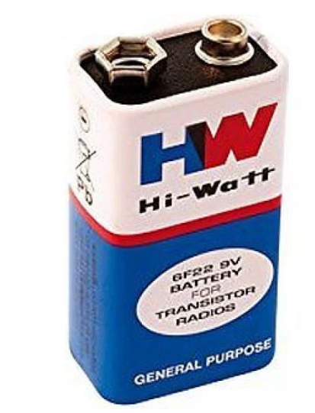

1. **Misc. components:**

10K resistors, 0.1uF ceramic capacitor, 10uF cylindrical capacitor.

**SCHEMATIC:**

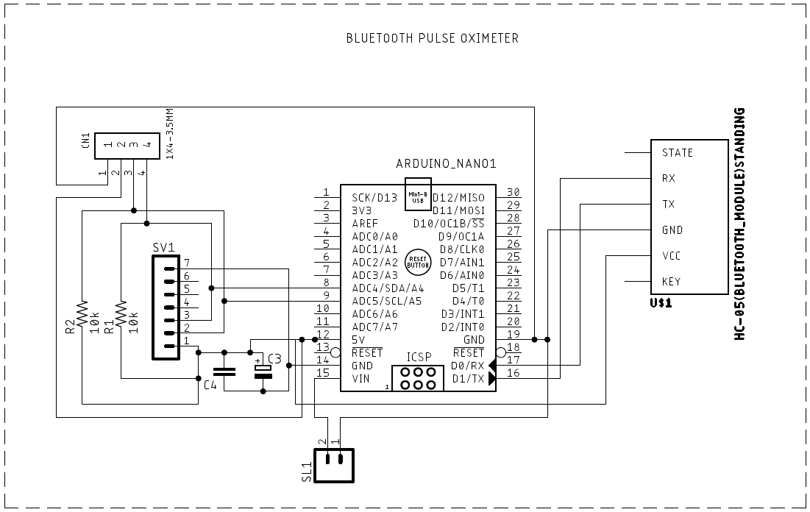

**Brief description of the schematic:**

The connections of all the above-mentioned components are as shown in the schematic.

Elaboration is however required for the exact use of the misc. components mentioned above (resistors and capacitors)

The two 10K resistors are the pull-up resistors (without which we found out that the sensor wouldn’t work in a desired way)

**What are pull-up resistors?**

In electronic logic circuits, a **pull-up resistor** or **pull-down resistor** is a resistor used to ensure a known state for a signal. It is typically used in combination with components such as switches and transistors, which physically interrupt the connection of subsequent components to ground or to VCC. Closing the switch creates a direct connection to ground or VCC, but when the switch is open, the rest of the circuit would be left floating (i.e., it would have an indeterminate voltage).

Use of capacitors: there basic function is to reduce the high frequency and low frequency noise (filtering purposes).

The M02 is placed for the external power source to drive the circuit (which as of now is not decided, most probably a 9v battery).

**PCB LAYOUT:**

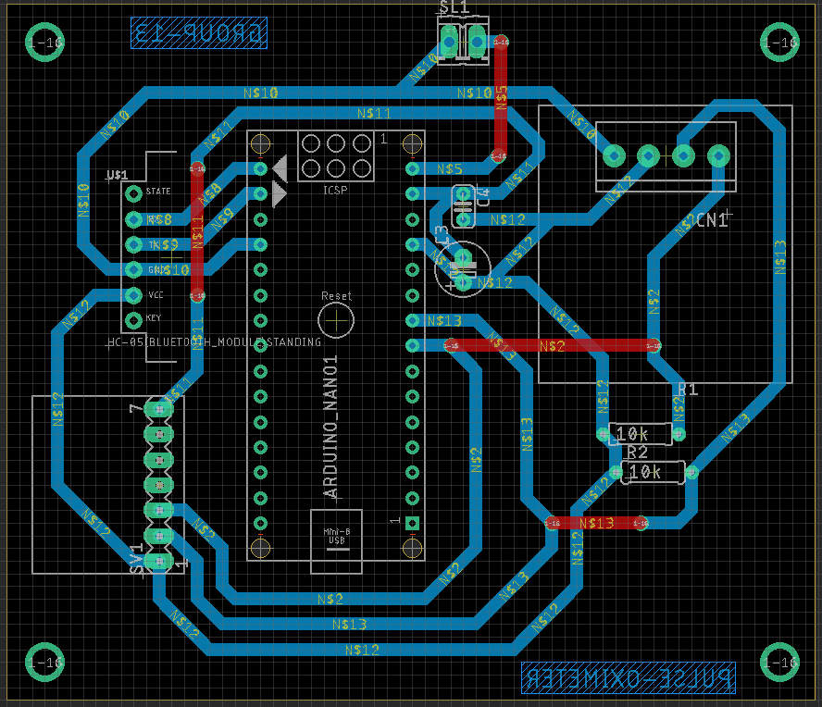

**FABRICATED PCB:**

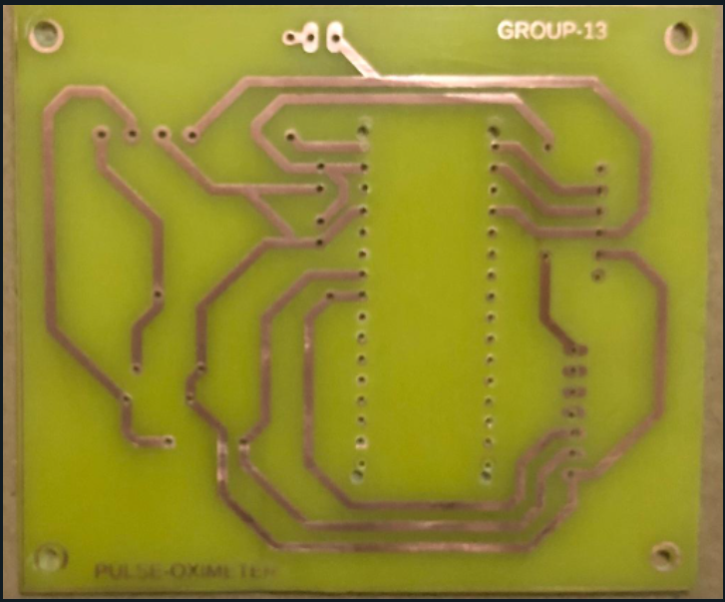

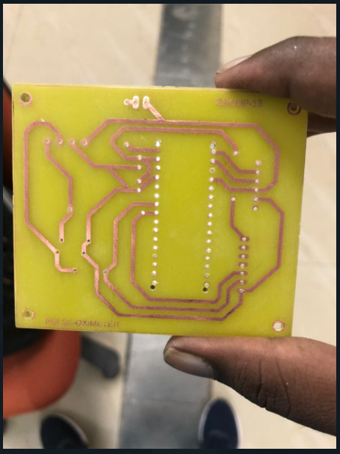

**IMAGES OF THE ENCLOSURE**

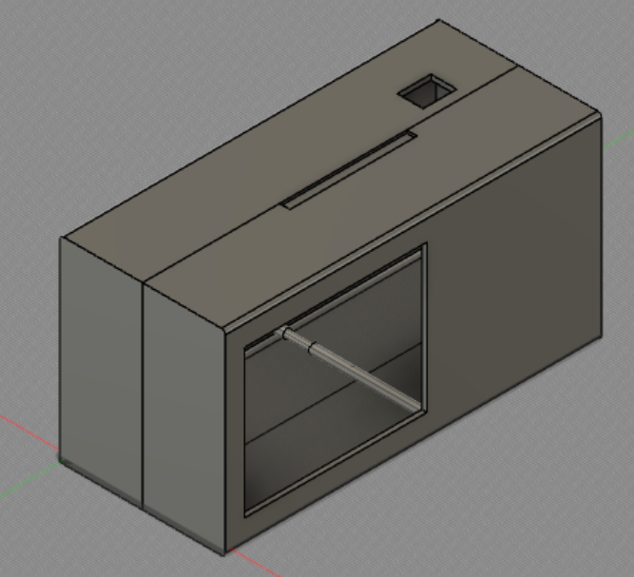

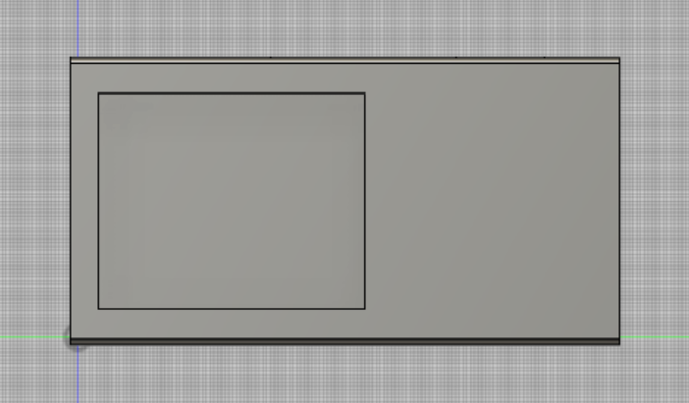

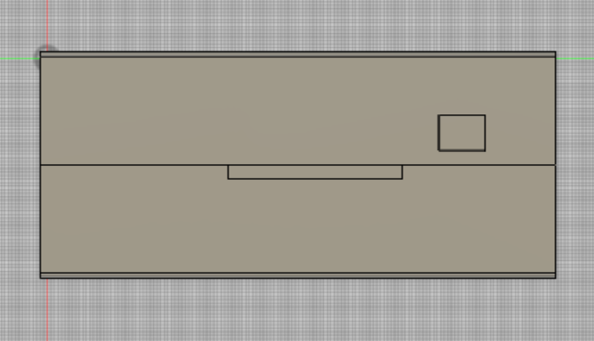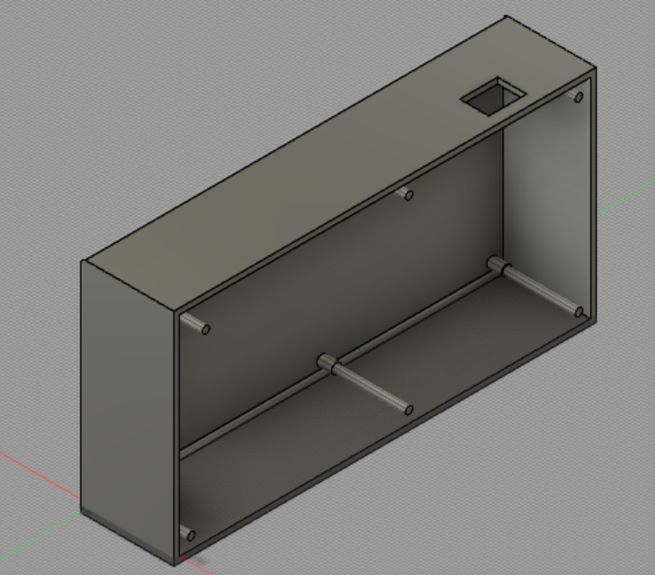

**GANTT CHART FOR THE PROJECT**

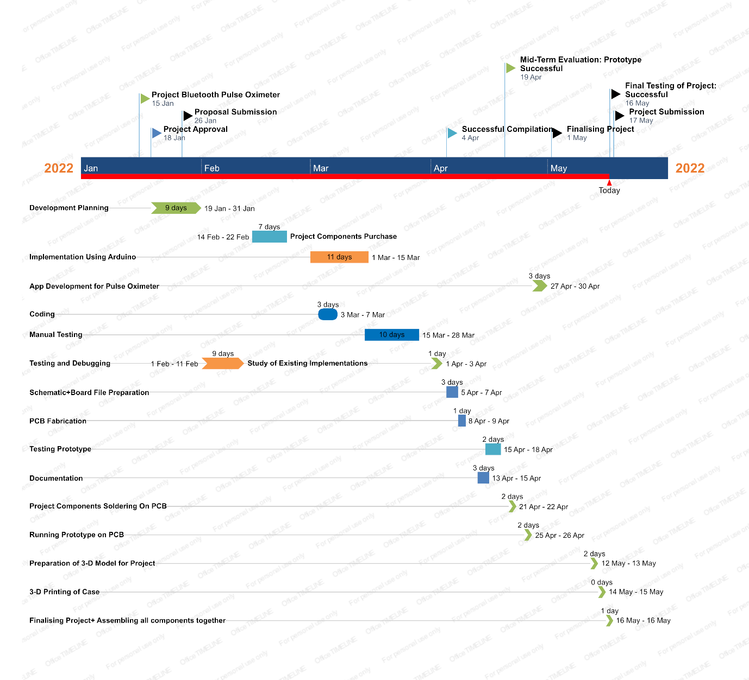

Aduino code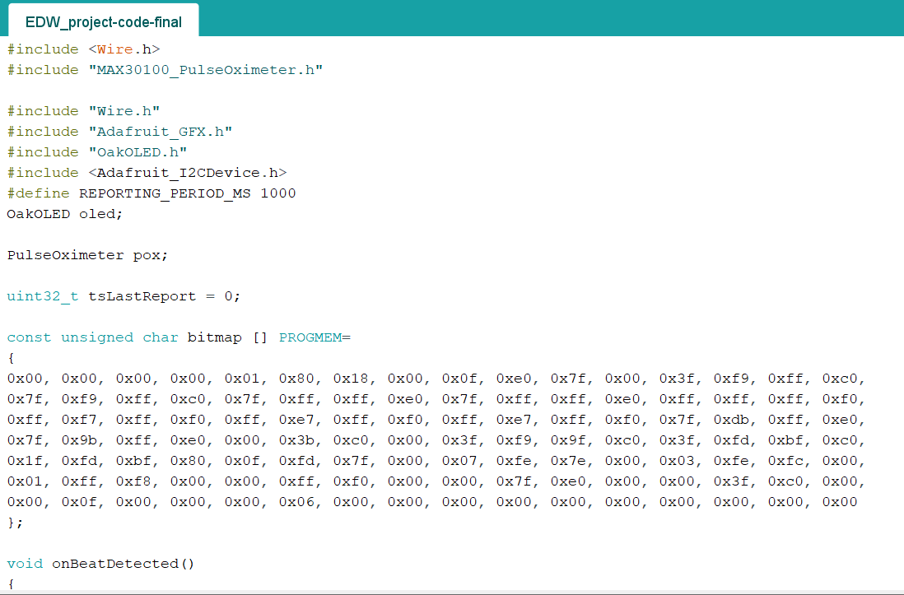

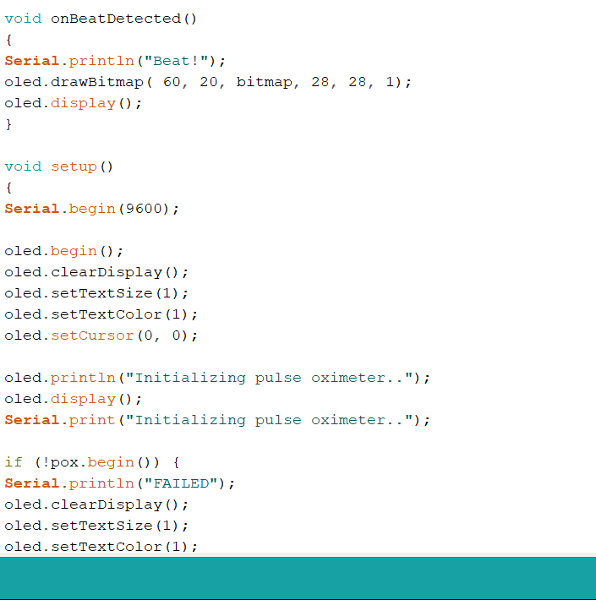

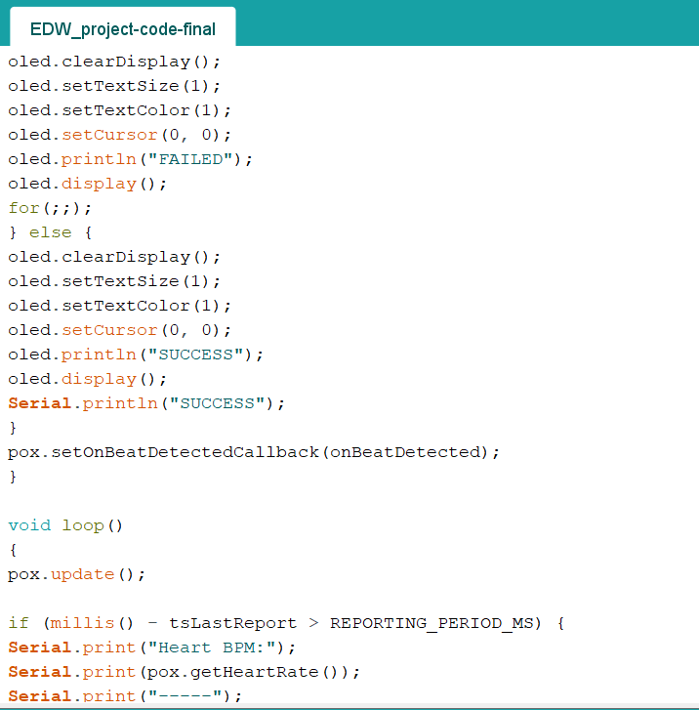

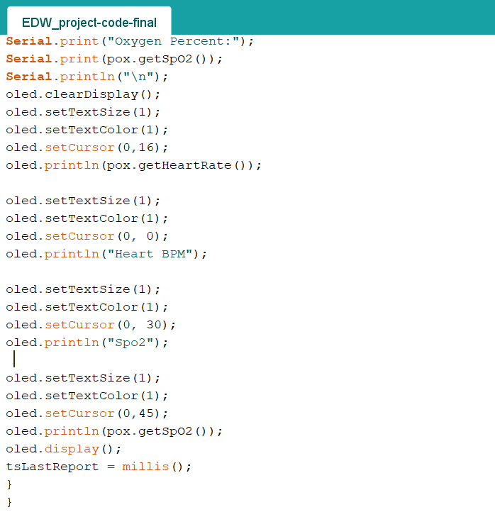

**SOFTWARE USED:**  
**Autodesk Eagle** **CAD** for PCB designing  
**Autodesk Fusion 360** for enclosure designing  
**Arduino IDE** for the Arduino code

**Note**: for more detailed information on the project and the how to replicate it checkout the GitHub repository link given below:  
<https://github.com/Blackeye-101/EDW-Project>